Satish Chandra Memorial School
Worksheet
- See the pictures and write the beginning sound in small letter; 2. Match according opposite word:-
______________________________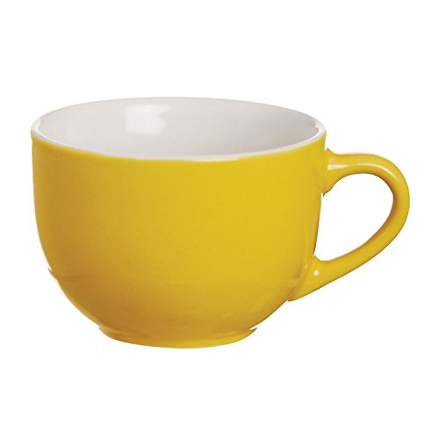
______________________________
______________________________
_______________________________
_______________________________
_______________________________
________________________________
________________________________
_______________________________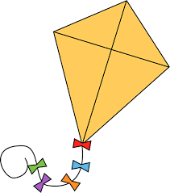
________________________________
-________________________________
_________________________________
______________________________
_____________________________
______________________________
_______________________________
______________________________
______________________________
______________________________
_______________________________


- ক্রমানুযায়ী সাজিয়ে লেখো :-
আ ই অ ঈ ঊ উ
__________ __________ __________ __________ __________ __________
__________ __________ __________ __________ __________ __________

- Draw flow as per given numbers :-

6 3 5

